CHAPTER 5: Ecosystems — flow of energy and matter
Worksheet 5.4

Cycling of materials
Science Quest 9: pages 213–7
Answers
1. The diagram below shows the carbon, water and nitrogen cycles. Match the listed words to the code letters in the diagram.
carbon dioxide gas | decomposers | evaporation | transpiration
ammonia in soil | burning fossil fuels | producer | nitrogen gas
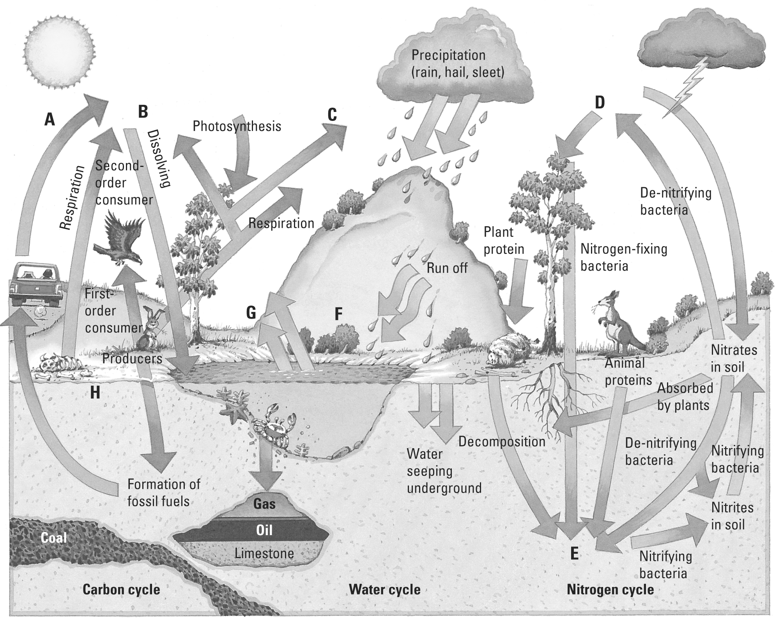
Burning fossil fuels
Carbon dioxide gas
A: B:
Transpiration
Nitrogen gas
C: D:
Ammonia in soil
Evaporation
E: F:
Producer
Decomposers
G: H:
2. Explain the importance of transpiration in the water cycle.
Plants absorb water from the soil through their roots. Using the sun’s energy, water exits the leaf surface and re-enters the atmosphere as water vapour.

CHAPTER 5: Ecosystems — flow of energy and matter
Worksheet 5.4

Page 2

3. Explain the importance of the nitrogen cycle to plants and animals.
Plants and animals require proteins for their bodies. Proteins are composed of amino acids that contain the element nitrogen. Thus the nitrogen cycle is essential to produce the nitrogen compounds that are precursors for amino acid production.

4. Explain how the combustion of fossil fuels has altered the natural balance of the environment.
Carbon dioxide from the combustion of fossil fuels such as petrol and coal is released to the atmosphere. The carbon that was present in the fossil fuel that had been buried for millions of years now adds a greenhouse burden to the atmosphere that leads to global warming.

